**Problem Statement**

In 2019, Mayor of Boston appointed Boston PD’s new Police Commissioner. The new Commissioner came with a new mindset and new ideas of how to make his task force more effective and efficient. He came to know that Boston PD had employed a new Crime Reporting System in June 2015. He wanted to fully utilize the insights provided by the system to efficiently allocate resources and make his task force more effective in keeping the crime rate down in Boston.

**Our Dataset**

Crime incident reports are provided by Boston Police Department (BPD) to document the initial details surrounding an incident to which BPD officers respond. This is a dataset containing records from the new crime incident report system, which includes a reduced set of fields focused on capturing the type of incident as well as when and where it occurred. After cleaning blank and corrupted records, our data set has 348614 records. It has the following data points relevant to this study:

1. **Incident Number:** Each record has a unique incident number.
2. **Offense_Code_Group**: It defines what type of incident the report was filed for.
3. **Occurred_On_Date**: Date and Time of the reported incident.
4. **Year**: We sliced off the year from the Occured_On_Date for ease of analysis.
5. **Month**: We sliced off the month from the Occured_On_Date for ease of analysis. Values from 1 to 12 denoting the months.
6. **Day_Of_Week**: Denotes the day of the week when the incident occurred.
7. **Street**: Name of the Street on which the incident occurred.
8. **Lat & Long**: The latitude and longitude of the crime scene.

**Analysis**

**Visualization 1:** Total Number of incidents grouped by Street (Number of Incidents>1000)

We used PowerBI to plot the latitude and longitude of the streets on which the most incidents occur. We created a new measure, namely, Total_Records which helped us analyze how many incidents occur on each street. The Visualization shows the streets with more than 1000 recorded number of incidents. Washington Street leads with 17994. We expect that this analysis will help the Commissioner to allocate personnel and resources effectively. Proper allocation, in turn, will help for the Police to be more efficient and reduce the number of incidents that happen on these streets.

**Visualization 2:** Total Number of incidents grouped by Offence Code (Number of Incidents>2000)

We used Tableau workbook to create this visualization. It groups the incidents by offence code and shows only those categories with more than 2000 incidents, with Motor Vehicle Accidents leading with 32829 incidents, larceny following closely with 31155 incidents. We expect that this analysis will help the Commissioner to understand what type of incidents occur the most in Boston, so that, a specialized task force can be created to tackle the most regularly occurring incidents. For instance, a public awareness campaign can be started to educate people that can help reduce vehicular accidents in the city.

**Visualization 3:** Number of incidents grouped by Year, Month and Day of the Week

We created a dashboard comprised of 3 Tableau workbooks that show the number of incidents occurring yearly, monthly and on what day of the week most incidents occur. The data for 2015 is excluded because only 6 months’ worth of data was available that might have skewed the reporting for certain months and days of the week. We expect this visualization to be able to help the commissioner to allocate squad cars and personnel to be on patrol effectively. For instance, most crimes occur collectively in summer and on Fridays. The commissioner can increase patrolling in summer and during weekends.

**Conclusion**

We expect our analysis to be helpful for the new Police Commissioner to effectively and efficiently manage his Police Force. Alternate interpretations of our first visualization can suggest that most incidents happen on these streets because these areas of the city are where the low-income families live. Another interpretation can be that Washington Street is a hotspot because there may be no police station nearby. Therefore, you can establish a new police station nearby. Alternate interpretations of our second visualization can say that most incidents are related to vehicular accidents because of poor infrastructure of the city. They can suggest that if we improve the infrastructure, namely, roads, traffic lights and stops, etc.; we can reduce the number of vehicular incidents. An alternate interpretation of the third visualization can say that since the number of incidents have remained fairly similar in the last 3 years, the last commissioner was not effective with his police force and did not fully utilize the insights provided by this new reporting system.

Footnote: We would like the instructor to play the role of the Police Commissioner of Boston PD.

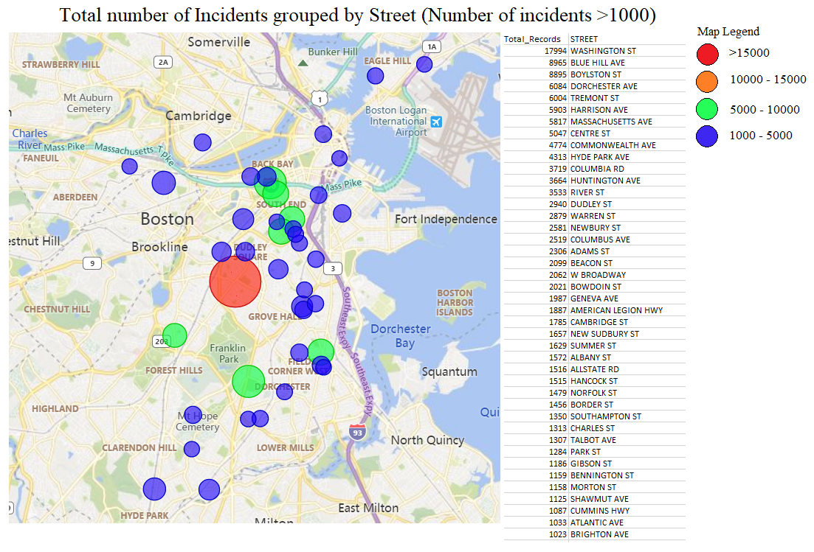

**Visualization 1:** Total Number of incidents grouped by Street (Number of Incidents>1000)

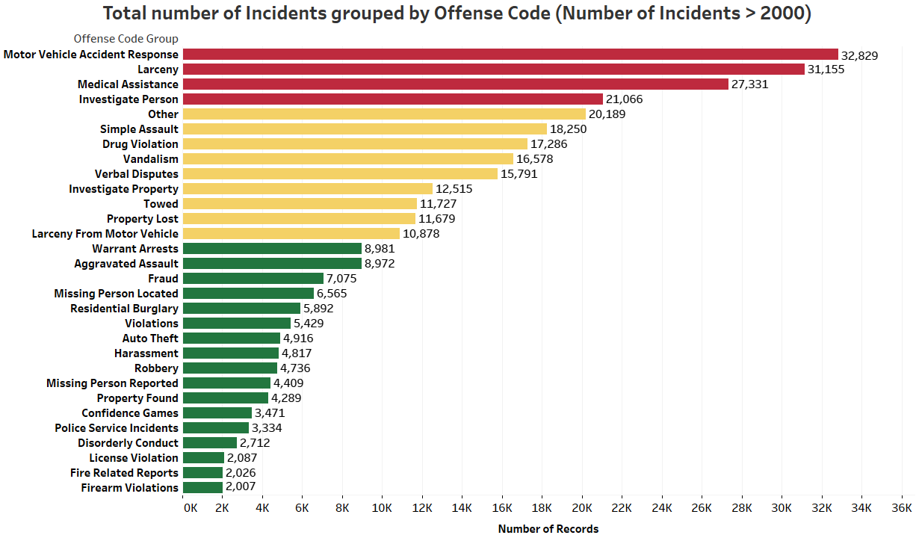

**Visualization 2:** Total Number of incidents grouped by Offence Code (Number of Incidents>2000)

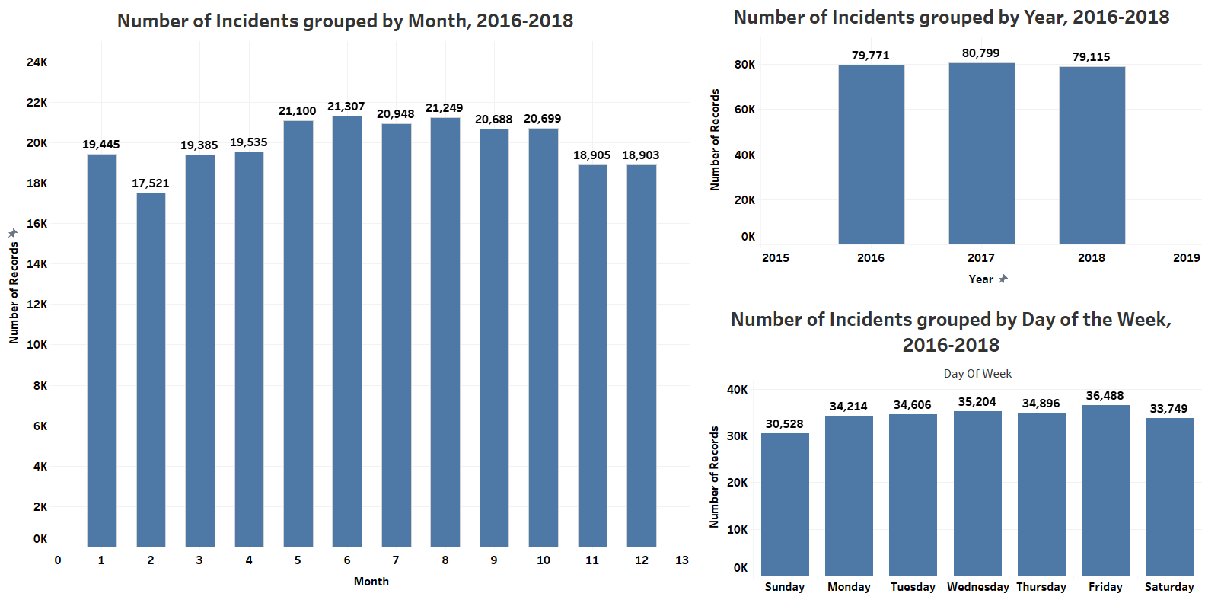

**Visualization 3:** Number of incidents grouped by Month, Year and Day of the Week